Effective: 8.28.20

Covid-19 BRM Operational Site Specific Guidance

To meet Governor Kemps Executive Order regarding COVID-19 and in addition to the State Parks and Historic Sites Operational Plan for all sites, the following procedures are being implemented:

- Site will only allow up to, but no more than, the number of visitors listed below inside the following facilities:
  - Trading Post: 2 guests/ 1 family unit – 1 employee Trading Post to be open Friday-Sunday
  - Park Office/Visitors Center: 4 – guests 3 employees. Visitors Center to be open Monday-Thursday.

- To maintain our numbers we will have full time staff member to monitor
  - Full-time staff member will be present at door to monitor number of visitors entering the park office/visitors center
  - Continue with offering check-in services over the phone but still giving them the option to check in at the office

- Other methods taken to accommodate limited access, while protecting staff and our visitors, and ensure social distancing guidelines are followed: (example: moving cash registers, yellow floor tape, etc.)
  - Yellow tape will be placed for visitor distancing
  - Orange arrows will be placed on the floor to help encourage one direction shopping. This will also help with people entering the check-out line

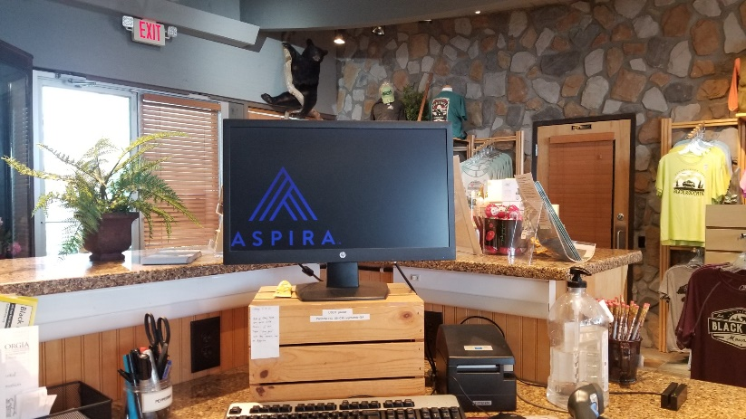
- Plexiglass will be placed on the left side of this computer by inserting it into wood to sit on the counter. The right side of the counter will have plexiglass hanging with a space on the bottom at the approximate height of the sanitizer bottle. There doesn’t seem to be a real option for moving the register.
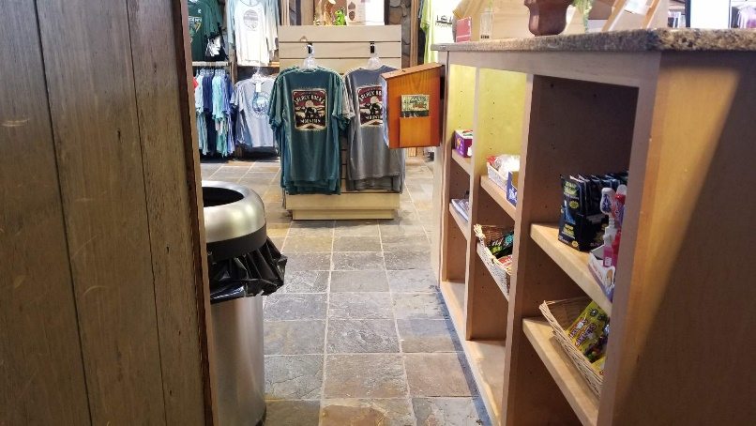
- Since the first computer on the counter will be the only one used. A chain will be placed so that people do not walk beyond the plexiglass on that side of the counter. Often people think the bathrooms are located on the other side of the counter.
- Hand sanitizer will be placed at the entrance of the Visitors Center
- Social distancing signage will be placed at the Visitors Center entrance
- Counters will be wiped as often as possible and with a minimum of wiping after ever visitor who makes a purchase
- Bathrooms will be disinfected and checked every hour and will be closed temporarily for cleaning as often as needed.
- Customers should not be allowed to try on clothing prior to purchasing. Returned clothing/refunds are allowed and the returned clothing should remain unavailable from public purchase for 7 days after return.
- Where possible doors can be left open for fresh air and to limit touching of door-handles

